**Gull Ahmed Men kameez Shalwar Winter Collection**

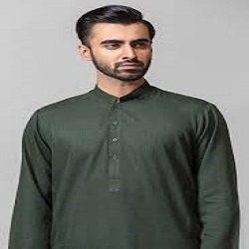

DARK GREEN KAMEEZ SHALWAR

PKR4992.00

* Jacquard Shirt: 3.5Meters
* Trouser: 3.5 Meter
* Size: Medium

**MORE INFORMATION:**

* color: Green
* Wear Type: Semi-Formal
* Product Category: Semi-Formal Kameez Shalwar
* Volume : Volume 4 2021
* Collection: Festive Affair '22
* Fabric: cotton
* Size Available: Small , Medium ,Large
* Disclaimer: Due to the photographic lighting & different screen calibrations, the colors of the original product may slightly vary from the picture